When a rigid-body rotates (with possibly time-variable orientation and angular velocity) its orientation, angular velocity, angular momentum and moment of inertia tensor are coordinate dependent, and may be given in two distinct frames of reference:
- inertial, space or world frame of reference
- non-inertial, body-fixed or rotational frame of reference

Equation (7.47)
Here, the time derivative of the orientation quaternion is expressed in inertial (world) frame of reference as
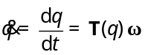 Eq. (7.47) ⬄ 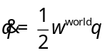
where 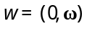 is angular velocity quaternion in world coordinates (inertial frame) and 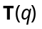 is a matrix according to (7.48) that corresponds to ½ of the right side multiplication with quaternion q, i.e. since
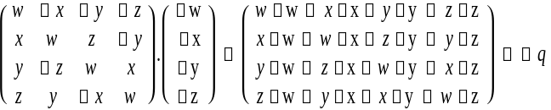
which holds for any two quaternions  = ( w, x, y, z ) and q = ( w, x, y, z ).
Similarly, the time derivative of the orientation can be expressed in a body-fixed frame as
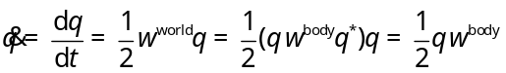 i.e. 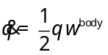

Equation (7.56), Euler’s equation
This equation is the major source of confusion, since Euler’s equation is actually specified in body-fixed (non-inertial frame, see [1]), as it follows from the general proposition
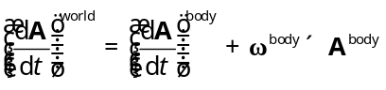
which is valid for any vector (also for in particular). Thus, Eq. (7.56)
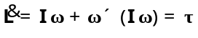
means

i.e.
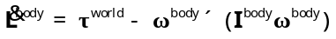
where 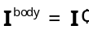 is principal moment of inertia, which is constant in the body-fixed frame.

To make all this more clear, different flavors of the algorithm for rigid body motion in 3D are summarized in the following table, depending whether , or are specified in the world or the body-fixed reference frame, and whether gyroscopic effect is accounted for (included) or ignored (ignored as to increase stability of the algorithm for low-order integrator methods).

Inertial (space or world) frame |  | Body-fixed (rotational) frame
with gyroscopic effect included | with gyroscopic  effect ignored | with gyroscopic  effect included | with gyroscopic  effect ignored
Linear part (specified always in inertial frame since attached to barycenter that does not rotate):
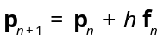 and 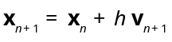
where the velocity is derived quantity 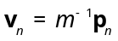
Angular part (frame dependent):
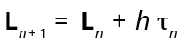 | 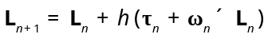 | 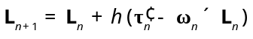 | 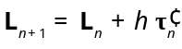
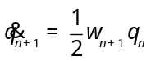 where 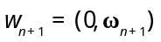 |  | 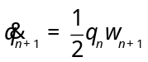 where
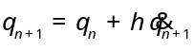
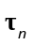 is in inertial frame |  | 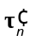 in body-fixed frame is 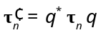
Derived quantities:
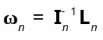
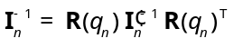 |  | 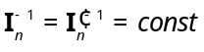
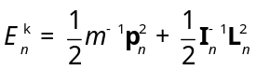
Notes: To transform any vector 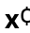 from body-fixed frame to in inertial frame do 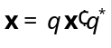. E.g. the relation between the total torque in inertial frame and in body-frame is 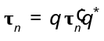. Note also that the orientation quaternion q is the same in both frames of reference, since 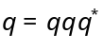.

References:
[1] Taylor, John R. – Classical Mechanics, University Science Books, 2005, pp. 394-396
[2] Severin, M. – Notes on Discrete Mechanics, April 18, 2011

